Householder development
Along with national validation requirements, you will need to submit local requirements:
Block plan
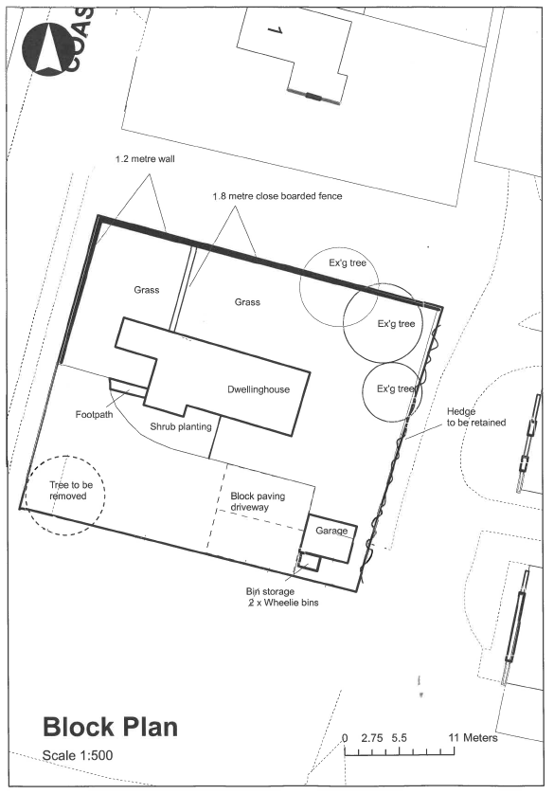
When required

All development proposals

What is required

Existing and proposed block plans showing:
- Boundary treatments (walls/fences etc.)
- Buildings / outbuildings within the site (e.g. sheds/garages)
- Parking area/space
- Neighbouring properties (including location of windows, doors or other openings that may be affected by the development)
- Existing trees

Further help

Example block plan:

Flood Risk Assessment
When required

All ground floor level development in flood zones 2 or 3 as identified by the Environment Agency maps.

What is required

Confirmation that proposed finished floor levels are no lower than existing (this can be annotated on the submitted drawings).

If they are to be lower than existing then a full flood risk assessment will be required.

Further help

The Environment Agency maps can be found here

Heritage assessment of significance and impact
When required

For proposals that affect a listed building, a curtilage listed building (a building built before 1948 within the curtilage or site of a listed building) or a scheduled ancient monument.

What is required

This should include an assessment of the significance of the heritage asset(s) (e.g. listed building), an assessment of the impact on the significance of the heritage asset and a justification for the proposed works. For works that affect a listed building or the setting of a listed building this should include the list description.

For applications affecting a listed building, you should also submit photos of the relevant part(s) of the listed building (interior and exterior) and its grounds / garden.

Further help

You can search Historic England’s list of listed buildings here
Our interactive map can show you if a building is listed

Significance means “The value of a heritage asset to this and future generations because of its heritage interest. That interest may be archaeological, architectural, artistic or historic. Significance derives not only from a heritage asset's physical presence, but also from its setting”.

Levels survey
When required

Where ground levels are changing by more than 0.3 metres or where a raised platform (e.g. decking) is proposed.

What is required

A plan showing the proposed ground levels relative to existing ground levels. This can be shown by cross section.

